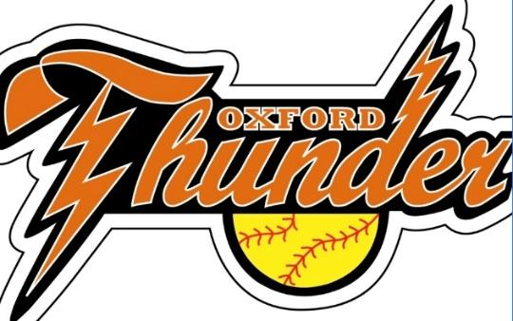
Oxford Lassie League
BOD Meeting Minutes
1/3/2024

Newly Elected Board of Directors Officers:
  - President – Kerry Russell
  - Vice President – Scott Burlingame
  - Treasurer – Sheri Abrahamson
  - Secretary/Publicity Clerk/Sponsorships – Liz Coghlan
  - Field Manager/Twin Valley Coordinator – Ross Coghlan
  - Grounds Maintenance Coordinator-Dana Iverson
  - Umpire Coordinator/Equipment Coordinator- Beth Joseph
  - 10 and Under Development Coordinator- Josh Dolbec
  - Apparel Manager- Courtney Skeates
  - Fundraising Coordinator- Erica Peters-Skowron
  - Concession Coordinators- Michelle Davis and Jessica Dolbec
  - Past President Advisor- Jane Dupuis

Treasury News
$11,591.93 (Bank Balance as of 1/3/2024)
-$2500.00 for Energy Baseball coming out

Registration for Spring 2024 – Began in November.
- 8U-3
- 10U-3
- 12U-2
- 14U-2

New Business
-Tentative Clinic Dates 3/2, 3/9, 3/16, 3/23 for OMS.
-Registration end date 3/30?
-Vote for Player Agent- what does this job include?
-Vote for use of Squad Locker for uniforms/apparel?
- Vote what to use $500 Dicks Sporting Goods giftcard for?
-Vote for SCSL (Charlton League) for 2024? Pros and Cons to joining again?
-Winter Festival on January 27th, pamphlets and bracelets all set? Families signed up to work the booth? Polar plunge update?
-Sponsorship and Fundraising ideas?
-Is anyone in need of CPR/AED training for this year?
-Ross with shed update. Picture included.
-Google Reviews discussion.
-Friends and Family weekend at Dick’s Sporting Goods 3/22-3/24.
- Post Office Box Keys-Pass on?
-Evaluations again in March?
-Begin Calendar Raffle scouting and card stock preparation. Bill said he would send the file for the Calendar raffle.
-WooSox Oxford Night is May 25th. We have purchased 150 tickets again.
-Meat Raffle for February or March at Days End?
-Ideas on having a Someone Special Dance or just a regular dance?
-Ideas on signing up for concessions? Sign-Up Genius? Pen and Paper at practice? Other ideas?
-Opening day tournament? Field of Screams date for 2024?
-Gaffney Soccer Tournament again?
-Community outreach ideas?

-Anything we didn’t cover?

